## **flutter与原生交互原理**

Flutter与Native之间的通信是采用双通道事件传递机制，通过MethodChannel进行传递数据，通信原理如下图（官网图片）

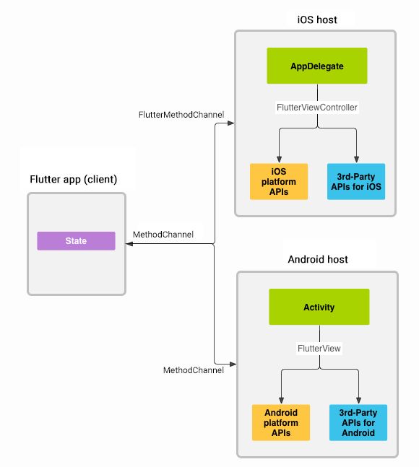

这里贴上官网的[文档地址](https://flutter.dev/docs/development/platform-integration/platform-channels" \t "https://segmentfault.com/a/_blank)，方便大家查阅，官网的获取充电的信息的例子网上也有很多，我就不带大家一起敲了，这里主要讲解一下与国内Badidu地图实战的过程方便大家加深理解

## **需求背景**

* 需求：需要在Flutter里面展示地图，并且能够进行点击，导航，定位等交互。
* 需求分析（实现方法）：

1. 采用Flutter组件库里面的google地图进行开发（能够快速开发，而且有成熟的api，但是由于在国内需要翻墙才能用google地图，而且基本是英文，所以弃用）
2. 使用webview嵌入Flutter程序进行开发（能够灵活的实现各种样式，但是每次都需要加载地图比较缓慢，暂不采用）
3. 使用原生的baidu地图与Flutter进行通信（增加了开发的工作量，但是能够很好的克服上面的缺点）

## **Flutter端代码**

首先Flutter程序里面先展示原生的Android Activity作为组件进行展示，然后创建MethodChannel和EventChannel对象进行事件进行传递，EventChannel用来监听事件，MethodChannel用来发送事件，原理很简单，大家不要想得太复杂，动手实现一下就能够明白

**import** 'package:flutter/material.dart';**import** 'package:flutter/services.dart';**import** 'package:my_project/widget/map_mood_card.dart';**import** 'mood_detailed_content.dart';**import** 'package:my_project/common/utils/navigator_utils.dart';**import** 'package:my_project/widget/shuofen_card.dart';**import** 'package:my_project/widget/xica_card.dart';

**class** **MapPage** **extends** **StatefulWidget** {

**const** MapPage({Key key}) : **super**(key: key);

**@override**

_MapPageState createState() => _MapPageState();

}

**class** **_MapPageState** **extends** **State**<**MapPage**> **with** **AutomaticKeepAliveClientMixin** {

**static** **const** platform = **const** MethodChannel('samples.flutter.io/getLocation');

*// 需要跟MainActivity中的一致（com.example.my_project/event）*

**static** **const** EventChannel eventChannel = **const** EventChannel('com.example.my_project/event');

bool isShowCard = **false**;

string eventString = '';

**@override**

**void** initState() {

print('-------------initState--------------');

**super**.initState();

eventChannel.receiveBroadcastStream().listen(_onEvent, onError: _onError);

}

**void** _onEvent(Object event) {

**this**.setState(() {

eventString = event;

});

print('-------------Message from native------------------' + event.toString());

}

**void** _onError(Object error) {

setState(() {

print(

'-------------Error occured on communicate between flutter and native------------------');

});

}

**@override**

**void** didChangeAppLifecycleState(AppLifecycleState state) {

print('-------------didChangeAppLifecycleState-------------$state-');

}

**@override**

**void** dispose() {

print('----------dispose---------------');

**super**.dispose();

}

**void** updateMapMarker() **async** {

**await** platform.invokeMethod('refrashMap', "我是参数");

}

*// This widget is the root of your application.*

**@override**

Widget build(BuildContext context) {

print('-------------build--------------');

updateMapMarker();

**return** Scaffold(

body: Stack(

children: <Widget>[

Center(

child: AndroidView(viewType: 'MyMap'),

),

],

));

}

**@override**

bool **get** wantKeepAlive => **true**;

}

## **Android端代码**

怎么配置baidu地图的sdk这里就不细说了，baidu地图的文档给开发者提供了相当详细的说明，在代码里面主要看中MethodChannel和EventChannel的功能，MethodChannel可以通过MethodCall监听Flutter程序事件发来的事件的数据，然后可以通过EventChannel进行发送数据回去，两者结合再一起则是双通道的通信机制。这里发送的数据格式有要求，格式如下（官网图片）

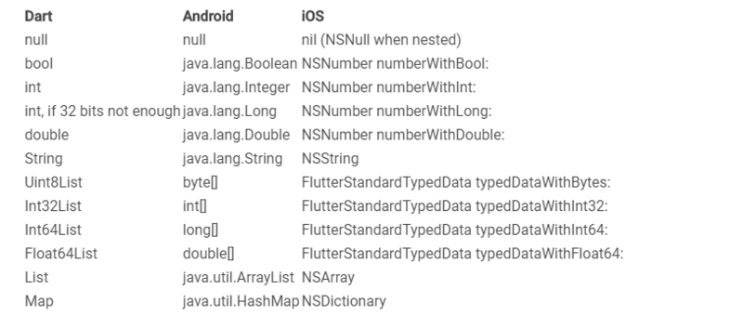

MainActivity.java

com.example.my_project

**import android.annotation.SuppressLint;import android.content.SharedPreferences;import android.graphics.Point;import android.os.Bundle;import android.os.Handler;import android.os.Message;import android.util.DisplayMetrics;import android.util.Log;import android.view.Gravity;import android.view.WindowManager;import android.widget.Toast;**

**import com.baidu.location.BDAbstractLocationListener;import com.baidu.location.BDLocation;import com.baidu.location.LocationClient;import com.baidu.location.LocationClientOption;import com.baidu.mapapi.map.BaiduMap;import com.baidu.mapapi.map.BitmapDescriptor;import com.baidu.mapapi.map.BitmapDescriptorFactory;import com.baidu.mapapi.map.MapStatus;import com.baidu.mapapi.map.MapStatusUpdate;import com.baidu.mapapi.map.MapStatusUpdateFactory;import com.baidu.mapapi.map.MapView;import com.baidu.mapapi.map.MyLocationConfiguration;import com.baidu.mapapi.map.MyLocationData;import com.baidu.mapapi.map.UiSettings;import com.baidu.mapapi.model.LatLng;**

**import org.jetbrains.annotations.NotNull;**

**import java.util.ArrayList;**

**import io.flutter.app.FlutterActivity;import io.flutter.plugin.common.EventChannel;import io.flutter.plugin.common.MethodCall;import io.flutter.plugin.common.MethodChannel;import io.flutter.plugin.common.MethodChannel.MethodCallHandler;import io.flutter.plugin.common.MethodChannel.Result;import io.flutter.plugins.GeneratedPluginRegistrant;**

**public** **class** **MainActivity** **extends** **FlutterActivity** {

**private** **final** String eventString = "event";

**private** **static** **final** String TAG = "MainActivity";

**private** **static** **final** String CHANNEL = "samples.flutter.io/getLocation";

**private** **static** **final** String eventChannel = "com.example.my_project/event";

**private** MethodChannel channel;

*// 后台服务器地址*

String host = null;

String locationText;

Double longitude, latitude;

**static** User user = **new** User("", "");

**private** **static** MapView mapView;

**private** **static** BaiduMap mBaiduMap;

**private** LocationClient mLocationClient;

**private** **static** String myId = null;

@Override

**protected** **void** onCreate(Bundle savedInstanceState) {

**super**.onCreate(savedInstanceState);

GeneratedPluginRegistrant.registerWith(**this**);

mapView = **new** MapView(**this**);

MapRegistrant.registerWith(**this**, mapView);

*//定位初始化*

mLocationClient = **new** LocationClient(**this**);

*//注册LocationListener监听器*

MyLocationListener myLocationListener = **new** MyLocationListener();

mLocationClient.registerLocationListener(myLocationListener);

*// 不显示百度地图Logo*

mapView.removeViewAt(1);

mBaiduMap = mapView.getMap();

*// 改变地图状态，使地图显示在恰当的缩放大小*

mMapStatus = **new** MapStatus.Builder().zoom(18.0f).build();

MapStatusUpdate mMapStatusUpdate = MapStatusUpdateFactory.newMapStatus(mMapStatus);

mBaiduMap.setMapStatus(mMapStatusUpdate);

mBaiduMap.setMyLocationEnabled(true);

mBaiduMap.setMyLocationConfiguration(**new** MyLocationConfiguration(

MyLocationConfiguration.LocationMode.FOLLOWING, true, null));

*//实例化UiSettings类对象*

UiSettings mUiSettings = mBaiduMap.getUiSettings();

*//禁用地图旋转功能，启用后对显示屏幕范围内的Marker有一定影响*

mUiSettings.setRotateGesturesEnabled(false);

*//禁用地图俯视功能*

mUiSettings.setOverlookingGesturesEnabled(false);

**new** MethodChannel(getFlutterView(), CHANNEL).setMethodCallHandler(

**new** MethodCallHandler() {

@Override

**public** **void** onMethodCall(MethodCall call, Result result) {

*// 在这个回调里处理从Flutter来的调用*

**switch** (call.method) {

**case** "getLocationDics":

**if** (locationText == "") {

result.success("地球的某一个角落");

**break**;

}

result.success(locationText);

**break**;

**case** "getLocationLongitude":

result.success(longitude);

**break**;

**case** "getLocationLatitue":

result.success(latitude);

**break**;

**case** "refrashMap":

**if** (user.getUserId() != "") {

mapView.onResume();

**if**(!isFirstMapRender) {

UpdateMapState();

}

Log.d("tag", call.arguments.toString());

result.success(null);

}

**break**;

**case** "setUserId":

mapView.onResume();

user.setUserId(call.arguments.toString());

result.success(null);

**break**;

**case** "setUserToken":

user.setToken(call.arguments.toString());

result.success(null);

**break**;

**case** "openGps":

addEmojiMarkers();

addUserTagBitMaps();

addUserTagBitMaps_Personal();

requestLocation();

result.success(null);

**break**;

}

}

}

);

*//设置地图渲染完成回调*

mBaiduMap.setOnMapRenderCallbadk(renderCallback);

*//设置地图状态监听*

mBaiduMap.setOnMapStatusChangeListener(listener);

}

**new** EventChannel(getFlutterView(), eventChannel).setStreamHandler(

**new** EventChannel.StreamHandler() {

@Override

**public** **void** onListen(Object args, **final** EventChannel.EventSink events) {

Log.d(TAG, "adding listener");

mBaiduMap.setOnMarkerClickListener(**new** BaiduMap.OnMarkerClickListener() {

events.success(eventString);*// 发送事件(eventString);*

}

**return** true;

}

});

}

@Override

**public** **void** onCancel(Object args) {

Log.d(TAG, "cancelling listener");

}

}

);

BaiduMap.OnMapRenderCallback renderCallback = **new** BaiduMap.OnMapRenderCallback() {

*/\*\**

*\* 地图渲染完成回调函数*

*\*/*

@Override

**public** **void** onMapRenderFinished() {

**if**(isFirstMapRender) {

Log.d("OnMapRenderCallback","地图首次渲染完成回调函数");

isFirstMapRender = false;

UpdateMapState();

} **else** **if**(isSecondMapRender) {

Log.d("OnMapRenderCallback","地图二次渲染完成回调函数");

isSecondMapRender = false;

UpdateMapState();

}

}

};

BaiduMap.OnMapStatusChangeListener listener = **new** BaiduMap.OnMapStatusChangeListener() {

*/\*\**

*\* 手势操作地图，设置地图状态等操作导致地图状态开始改变。*

*\**

*\* @param status 地图状态改变开始时的地图状态*

*\*/*

@Override

**public** **void** onMapStatusChangeStart(MapStatus status) {

}

*/\*\**

*\* 手势操作地图，设置地图状态等操作导致地图状态开始改变。*

*\**

*\* @param status 地图状态改变开始时的地图状态*

*\**

*\* @param reason 地图状态改变的原因*

*\*/*

*//用户手势触发导致的地图状态改变,比如双击、拖拽、滑动底图*

*//int REASON_GESTURE = 1;*

*//SDK导致的地图状态改变, 比如点击缩放控件、指南针图标*

*//int REASON_API_ANIMATION = 2;*

*//开发者调用,导致的地图状态改变*

*//int REASON_DEVELOPER_ANIMATION = 3;*

@Override

**public** **void** onMapStatusChangeStart(MapStatus status, int reason) {

}

**private** **void** requestLocation() {

*//通过LocationClientOption设置LocationClient相关参数*

LocationClientOption option = **new** LocationClientOption();

option.setOpenGps(true); *// 打开gps*

option.setCoorType("bd09ll"); *//坐标类型*

option.setIsNeedLocationDescribe(true);

*//设置locationClientOption*

mLocationClient.setLocOption(option);

*//开启地图定位图层*

mLocationClient.start();

}

**public** **class** **MyLocationListener** **extends** **BDAbstractLocationListener** {

@Override

**public** **void** onReceiveLocation(BDLocation location) {

*//mapView 销毁后不在处理新接收的位置*

**if** (location == null || mapView == null){

**return**;

}

locationText = location.getLocationDescribe();

longitude = location.getLongitude();

latitude = location.getLatitude();

MyLocationData locData = **new** MyLocationData.Builder()

.accuracy(0)

*// 此处设置开发者获取到的方向信息，顺时针0-360*

.direction(location.getDirection()).latitude(location.getLatitude())

.longitude(location.getLongitude()).build();

mBaiduMap.setMyLocationData(locData);

}

}

}