|  |  |  |
| --- | --- | --- |
| 商品目录 | 排母 |  |
| 间距 | 2.54mm |  |
| 总孔位数 | 12 |  |
| 排数 | 2 |  |
| 插孔结构 | 2x6P |  |
| 行距 | 2.54mm |  |
| 安装类型 | 直插 |  |
| 塑高 | - |  |
| 触头材质 | 黄铜 |  |
| 触头镀层 | - |  |

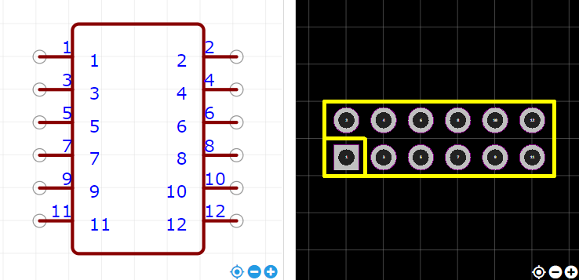

<https://item.szlcsc.com/37168.html>