|  |  |  |
| --- | --- | --- |
| 商品目录 | 排针 |  |
| 间距 | 2.54mm |  |
| 总PIN位数 | - |  |
| 排数 | - |  |
| 插针结构 | - |  |
| 行距 | 2.54mm |  |
| 安装类型 | 直插 |  |
| 圆针/方针 | - |  |
| 额定电流 | - |  |
| 额定电压 | - |  |
| 配合针长度 | - |  |
| 塑高 | 2.54mm |  |
| 触头材质 | 磷青铜 |  |
| 触头镀层 | - |  |
| 颜色 | 黑色 |  |

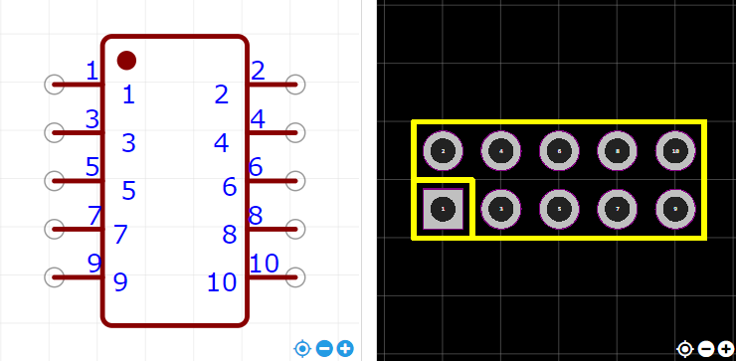

<https://item.szlcsc.com/214380.html>