|  |  |  |
| --- | --- | --- |
| 商品目录 | 音频连接器 |  |
| 连接器类型 | 3.5mm耳机座 |  |
| 额定电流 | - |  |
| 额定电压 | - |  |
| 工作温度范围 | - |  |

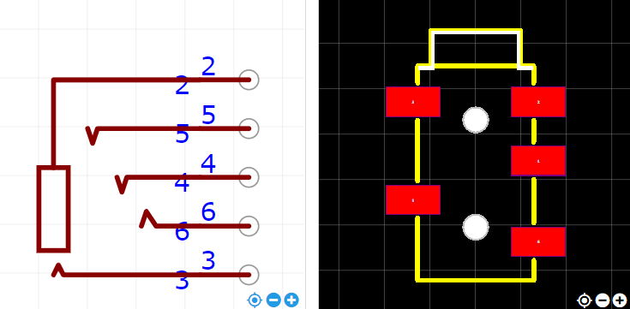

<https://item.szlcsc.com/3300106.html>