|  |  |  |
| --- | --- | --- |
| 商品目录 | 以太网连接器(RJ45 RJ11) |  |
| 连接器类型 | RJ插座 |  |
| USOC代码 | RJ45 |  |
| 端口数量 | 1 |  |
| 等级 | - |  |
| 屏蔽 | - |  |
| LED | 带LED |  |

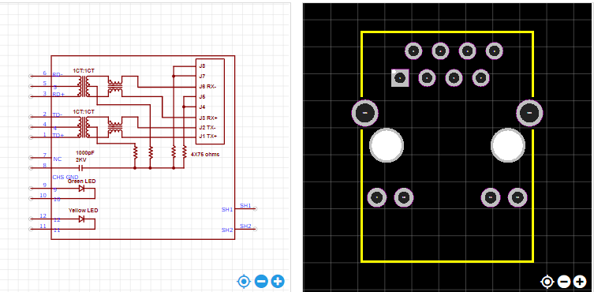

<https://item.szlcsc.com/12651.html>